Supplemental Information

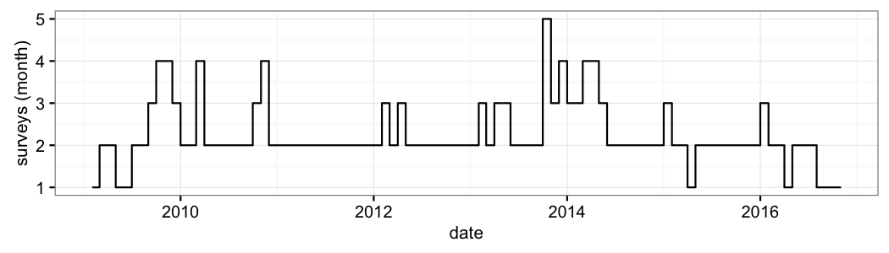

***Figure S1:*** *Survey effort. Number surveys per month during the study period.*

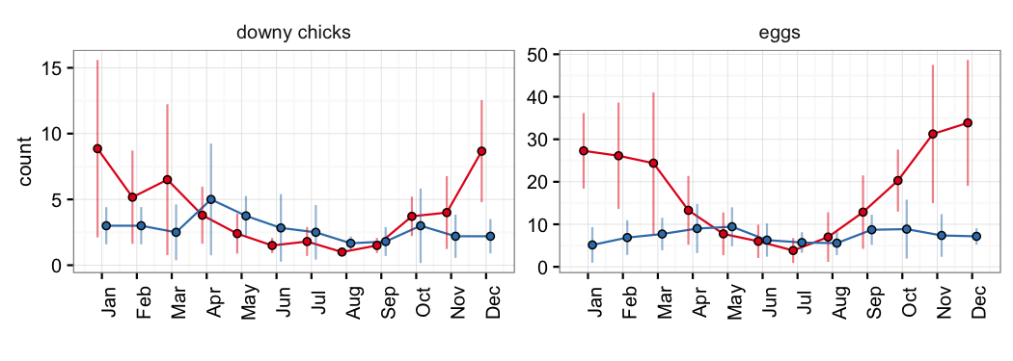

***Figure S2:*** *Mean number of observed downy chicks and eggs per month for P. rubricauda (red) and P. lepturus (blue). Vertical bars represent standard deviation of the observed values.*

***Box S1:*** *Summary table for model of new nest establishment for P. rubricauda.*

Family: poisson   
Link function: log   
  
Formula:  
n_new_nest ~ s(month) + s(as.numeric(date)) + n_surveys  
  
Parametric coefficients:  
 Estimate Std. Error z value Pr(>|z|)   
(Intercept) 1.73738 0.14172 12.259 <2e-16 ***  
n_surveys 0.06276 0.05752 1.091 0.275   
---  
Signif. codes: 0 '***' 0.001 '**' 0.01 '*' 0.05 '.' 0.1 ' ' 1  
  
Approximate significance of smooth terms:  
 edf Ref.df Chi.sq p-value   
s(month) 6.040 7.185 137.91 < 2e-16 ***  
s(as.numeric(date)) 5.134 6.249 35.11 6.5e-06 ***  
---  
Signif. codes: 0 '***' 0.001 '**' 0.01 '*' 0.05 '.' 0.1 ' ' 1  
  
R-sq.(adj) = 0.492 Deviance explained = 58.2%  
UBRE = 1.2221 Scale est. = 1 n = 86

***Box S2:*** *Summary table for model of new nest establishment for P. lepturus*

Family: poisson   
Link function: log   
  
Formula:  
n_new_nest ~ s(month) + s(as.numeric(date)) + n_surveys  
  
Parametric coefficients:  
 Estimate Std. Error z value Pr(>|z|)   
(Intercept) 0.66349 0.17634 3.763 0.000168 ***  
n_surveys 0.29967 0.06709 4.467 7.95e-06 ***  
---  
Signif. codes: 0 '***' 0.001 '**' 0.01 '*' 0.05 '.' 0.1 ' ' 1  
  
Approximate significance of smooth terms:  
 edf Ref.df Chi.sq p-value  
s(month) 1.851 2.313 2.477 0.327  
s(as.numeric(date)) 1.764 2.202 1.221 0.515  
  
R-sq.(adj) = 0.186 Deviance explained = 21.3%  
UBRE = 0.2251 Scale est. = 1 n = 83

***Table S1:*** *Model selection table for P. rubricauda. The best model included both location and date.*

|  |  |  |  |  |  |  |
| --- | --- | --- | --- | --- | --- | --- |
| location | date | df | logLik | AICc | delta | weight |
| ✓ | ✓ | 14 | -214.8 | 459.8 | 0.00 | 0.9997 |
| ✗ | ✓ | 8 | -229.5 | 476.4 | 16.54 | 0.0003 |
| ✗ | ✗ | 1 | -267.7 | 537.3 | 77.51 | 0.0000 |
| ✓ | ✗ | 6 | -261.7 | 537.5 | 77.69 | 0.0000 |

***Table S2:*** *Model selection table for P. lepturus. The best model included only date.*

|  |  |  |  |  |  |  |
| --- | --- | --- | --- | --- | --- | --- |
| location | date | df | logLik | AICc | delta | weight |
| ✗ | ✓ | 2 | -129.1 | 262.3 | 0.0000 | 0.5754 |
| ✗ | ✗ | 1 | -130.6 | 263.2 | 0.8965 | 0.3675 |
| ✓ | ✓ | 8 | -125.8 | 268.1 | 5.8390 | 0.0310 |
| ✓ | ✗ | 7 | -127.0 | 268.4 | 6.1932 | 0.0260 |

***Box S3:*** *Summary table for the most parsimonious model of nesting success for P. rubricauda. Picard was chosen as the baseline level for the location factor.*

Family: binomial   
 Link function: logit   
   
 Formula:  
 response ~ s(as.numeric(date)) + islet  
   
 Parametric coefficients:  
 Estimate Std. Error z value Pr(>|z|)   
 (Intercept) -0.421 0.413 -1.02 0.30795   
 isletLG1 -2.388 0.771 -3.10 0.00195 **   
 isletLG13 -1.416 0.477 -2.97 0.00296 **   
 isletLG14 -2.443 0.632 -3.87 0.00011 ***  
 isletLG17 -2.122 0.534 -3.98 7e-05 ***  
 isletLG18 -2.457 0.679 -3.62 0.00030 ***  
 isletLG8 -2.876 0.886 -3.25 0.00116 **   
 ---  
 Signif. codes: 0 '***' 0.001 '**' 0.01 '*' 0.05 '.' 0.1 ' ' 1  
   
 Approximate significance of smooth terms:  
 edf Ref.df Chi.sq p-value   
 s(as.numeric(date)) 7.7 8.53 70.6 1e-11 ***  
 ---  
 Signif. codes: 0 '***' 0.001 '**' 0.01 '*' 0.05 '.' 0.1 ' ' 1  
   
 R-sq.(adj) = 0.163 Deviance explained = 19.7%  
 UBRE = -0.2562 Scale est. = 1 n = 633

***Box S4:*** *Summary table for the most parsimonious model of nesting success for P. lepturus. Picard was chosen as the baseline level for the location factor.*

Family: binomial   
 Link function: logit   
   
 Formula:  
 response ~ s(as.numeric(date))  
   
 Parametric coefficients:  
 Estimate Std. Error z value Pr(>|z|)   
 (Intercept) -1.717 0.162 -10.6 <2e-16 ***  
 ---  
 Signif. codes: 0 '***' 0.001 '**' 0.01 '*' 0.05 '.' 0.1 ' ' 1  
   
 Approximate significance of smooth terms:  
 edf Ref.df Chi.sq p-value   
 s(as.numeric(date)) 1 1 2.87 0.091 .  
 ---  
 Signif. codes: 0 '***' 0.001 '**' 0.01 '*' 0.05 '.' 0.1 ' ' 1  
   
 R-sq.(adj) = 0.00558 Deviance explained = 1.12%  
 UBRE = -0.12644 Scale est. = 1 n = 302

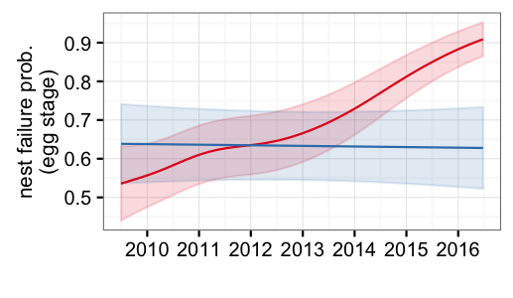

***Figure S3:*** *Probability of nesting failure at the egg stage for P. rubricauda (red) and P. lepturus (blue).*

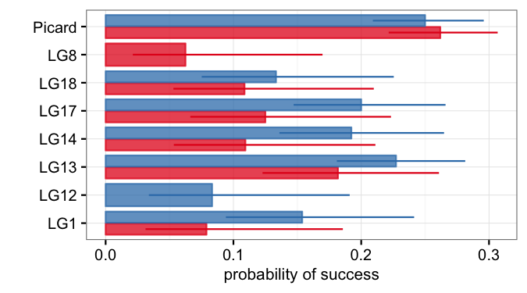

***Figure S4:*** *Probability of nesting success in different locations for P. rubricauda (red) and P. lepturus (blue).*